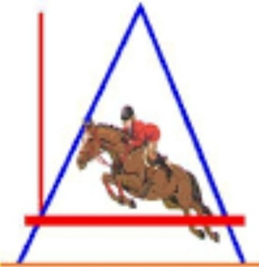
LOCHSIDE ARENA OPEN HORSE SHOW 16th JULY 2022
On Saturday 16TH July 2022
At Lochside Arena
Starting at 9AM prompt
Class fees are £7 to non-members and £4 for Lochside Arena Members
All entries to be returned to Amy Fraser, 19 Columbia Place, Stornoway, HS1 2TN no later than Saturday 9th July 2022
Payment can be made on PayPal using friends and family to lochsidearena@gmail.com
Class No | Horse’s Name | Height | Rider’s Name | Fee

Parent’s Name (if under 18 years old)
Address
Child’s Age
Contact No
Email Address

